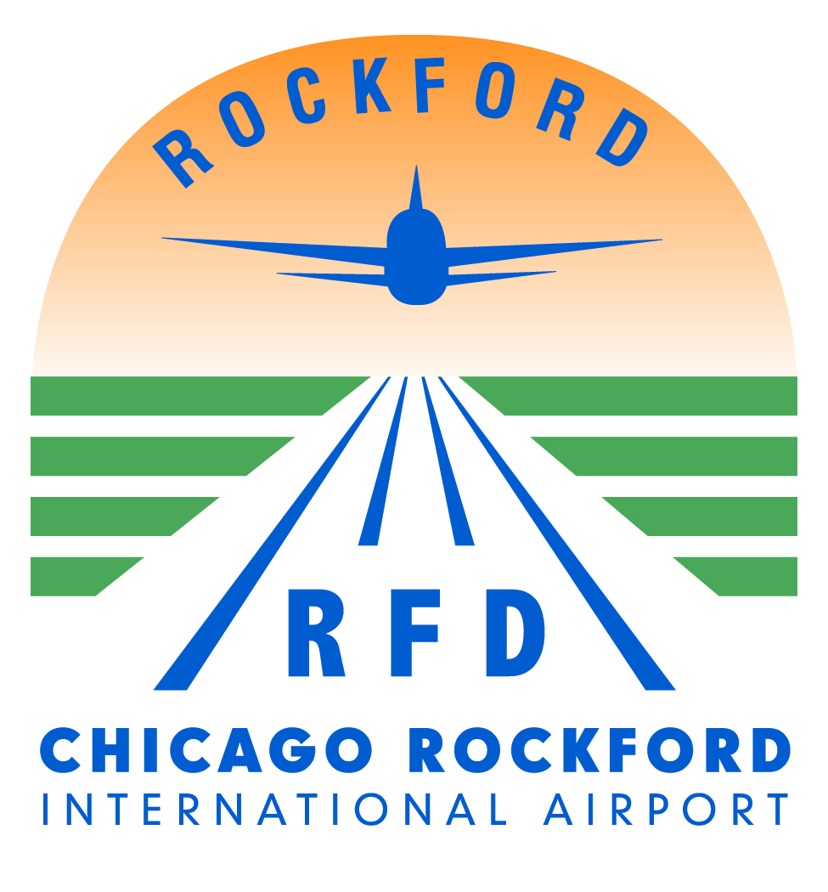

**Chicago Rockford International Airport (RFD)**

**Greater Rockford Airport Authority**

**Job Posting Date Posted: June 26, 2024**

Operations Specialist

The position requires the ability to perform airfield operations including but not limited to monitoring and controlling the use of the airport, providing information assistance to both airport users and public with excellent communication skills. An understanding of FAA part 139, 77, 150 and TSA 1542. The ability to perform in the airfield area and conduct various operational duties. Capable of working independently. Related experience, computer skills, and knowledge of airport operations a plus.

Chicago Rockford International Airport (RFD) is committed to providing exceptional people with opportunities to grow and be creative at one of the fastest growing airports in the United States.  The position requires the ability to work various shifts including evenings, weekends, and holidays.  Overtime required as needed, may increase due to seasonality.

All positions will require a valid Illinois driver’s license with a good driving record. Each position is subject to Federal Aviation Administration and Transportation Security Administration regulations.  Must pass a fingerprint-based criminal background check and drug screen. Degree in Aviation or a related field. Other combinations of experience and education that meet the minimum requirements may be substituted.

To apply for the position please email Michelle Cassaro, Deputy Director of Finance and Administration at [scassaro@flyrfd.com](mailto:scassaro@flyrfd.com)